Eligibility Center

Divisions I and II Initial-Eligibility Requirements

Core Courses

• NCAA Division I requires 16 core courses. NCAA Division II currently requires 14 core courses.
Division II will require 16 core courses for students enrolling on or after August 1, 2013. See the charts below.
• NCAA Division I will require 10 core courses to be completed prior to the seventh semester (seven of the 10 must be a combination of English, math or natural or physical science that meet the distribution requirements below). These 10 courses become "locked in" at the seventh semester and cannot be retaken for grade improvement.
o Beginning August 1, 2016, it witl be possible for a Division college-bound student-athlete to still receive athletics aid and the ability to practice with the team if he or she fails to meet the 1o course requirement, but would not be able to compete.

Test Scores

• Division I uses a sliding scale to match test scores and core grade-point averages (GPA). The sliding scale for those requirements is shown on Page No. 2 of this sheet.
• Division IIrequires a minimum SAT score of 820 or an ACT sum score of 68.
• The SAT score used for NCAA purposes includes only the critical reading and math sections. The writing section ofthe SAT is not used.
• The ACf score used for NCAA purposes is a sum of the following four sections: English, mathematics, reading and science.
• When you register for the SAT or ACT, use the NCAA Eligibility Center code of 9999 to ensure all SAT and ACT scores are reported directly to the NCAA Eligibility Center from the testing agency. Test scores that appear on transcripts will not be used.

Grade-Point Average

• Be sure to look at your high school's List of NCAA Courses on the NCAA Eligibility Center's website (www.eligibilitycenter.org). Only courses that appear on your school's List of NCAA Courses will be used in the calculation of the core GPA. Use the list as a guide.
• Division I students enrolling full time before August 1, 2016, should use Sliding Scale A to determine eligibility to receive athletics aid, practice and competition during the first year.
• Division I GPA required to receive athletics aid and practice on or after August 1, 2016, is 2.000 (corresponding test-score requirements are listed on Sliding Scale Bon Page No.2 of this sheet).
• Division I GPA requirea to e eligi.B e for competition on or after l\ugust 1, 201 , is 2.300 (corresponding test-score requirements are listed on Sliding Scale Bon Page No.2 of this sheet).
• The Division IIcore GPA requirement is a minimum of 2.000.
• Remember, the NCAA GPA is calculated using NCAA core courses only.

DIVISION I DIVISION II DIVISION II
16 Core Courses 14 Core Courses 16 Core Courses
4 years of English. 3 years of English. (2013 and After)
3 years of mathematics (Algebra I 2 years of mathematics (Algebra I 3 years of English.
or higher). or higher). 2 years of mathematics (Algebra I or
2 years of natural/physical science 2 years of natural/physical science higher).
(1 year of lab if offered by high (1 year of lab if offered by high 2 years of natural/physical science (1 school). school). year of lab if offered by high
year of additional English, 2 years of additional English, school).
mathematics or natural/physical mathematics or natural/physical 3 years of additional English, science. science. mathematics or natural/physical
2 years of social science. 2 years of social science. science.
4 years of additional courses (from 3 years of additional courses (from 2 years of social science.
any area above, foreign any area above, foreign 4 years of additional courses (from
language or comparative language or comparative any area above, foreign language religion/philosophy). religion/philosophy). or comparative religion/philosophy).

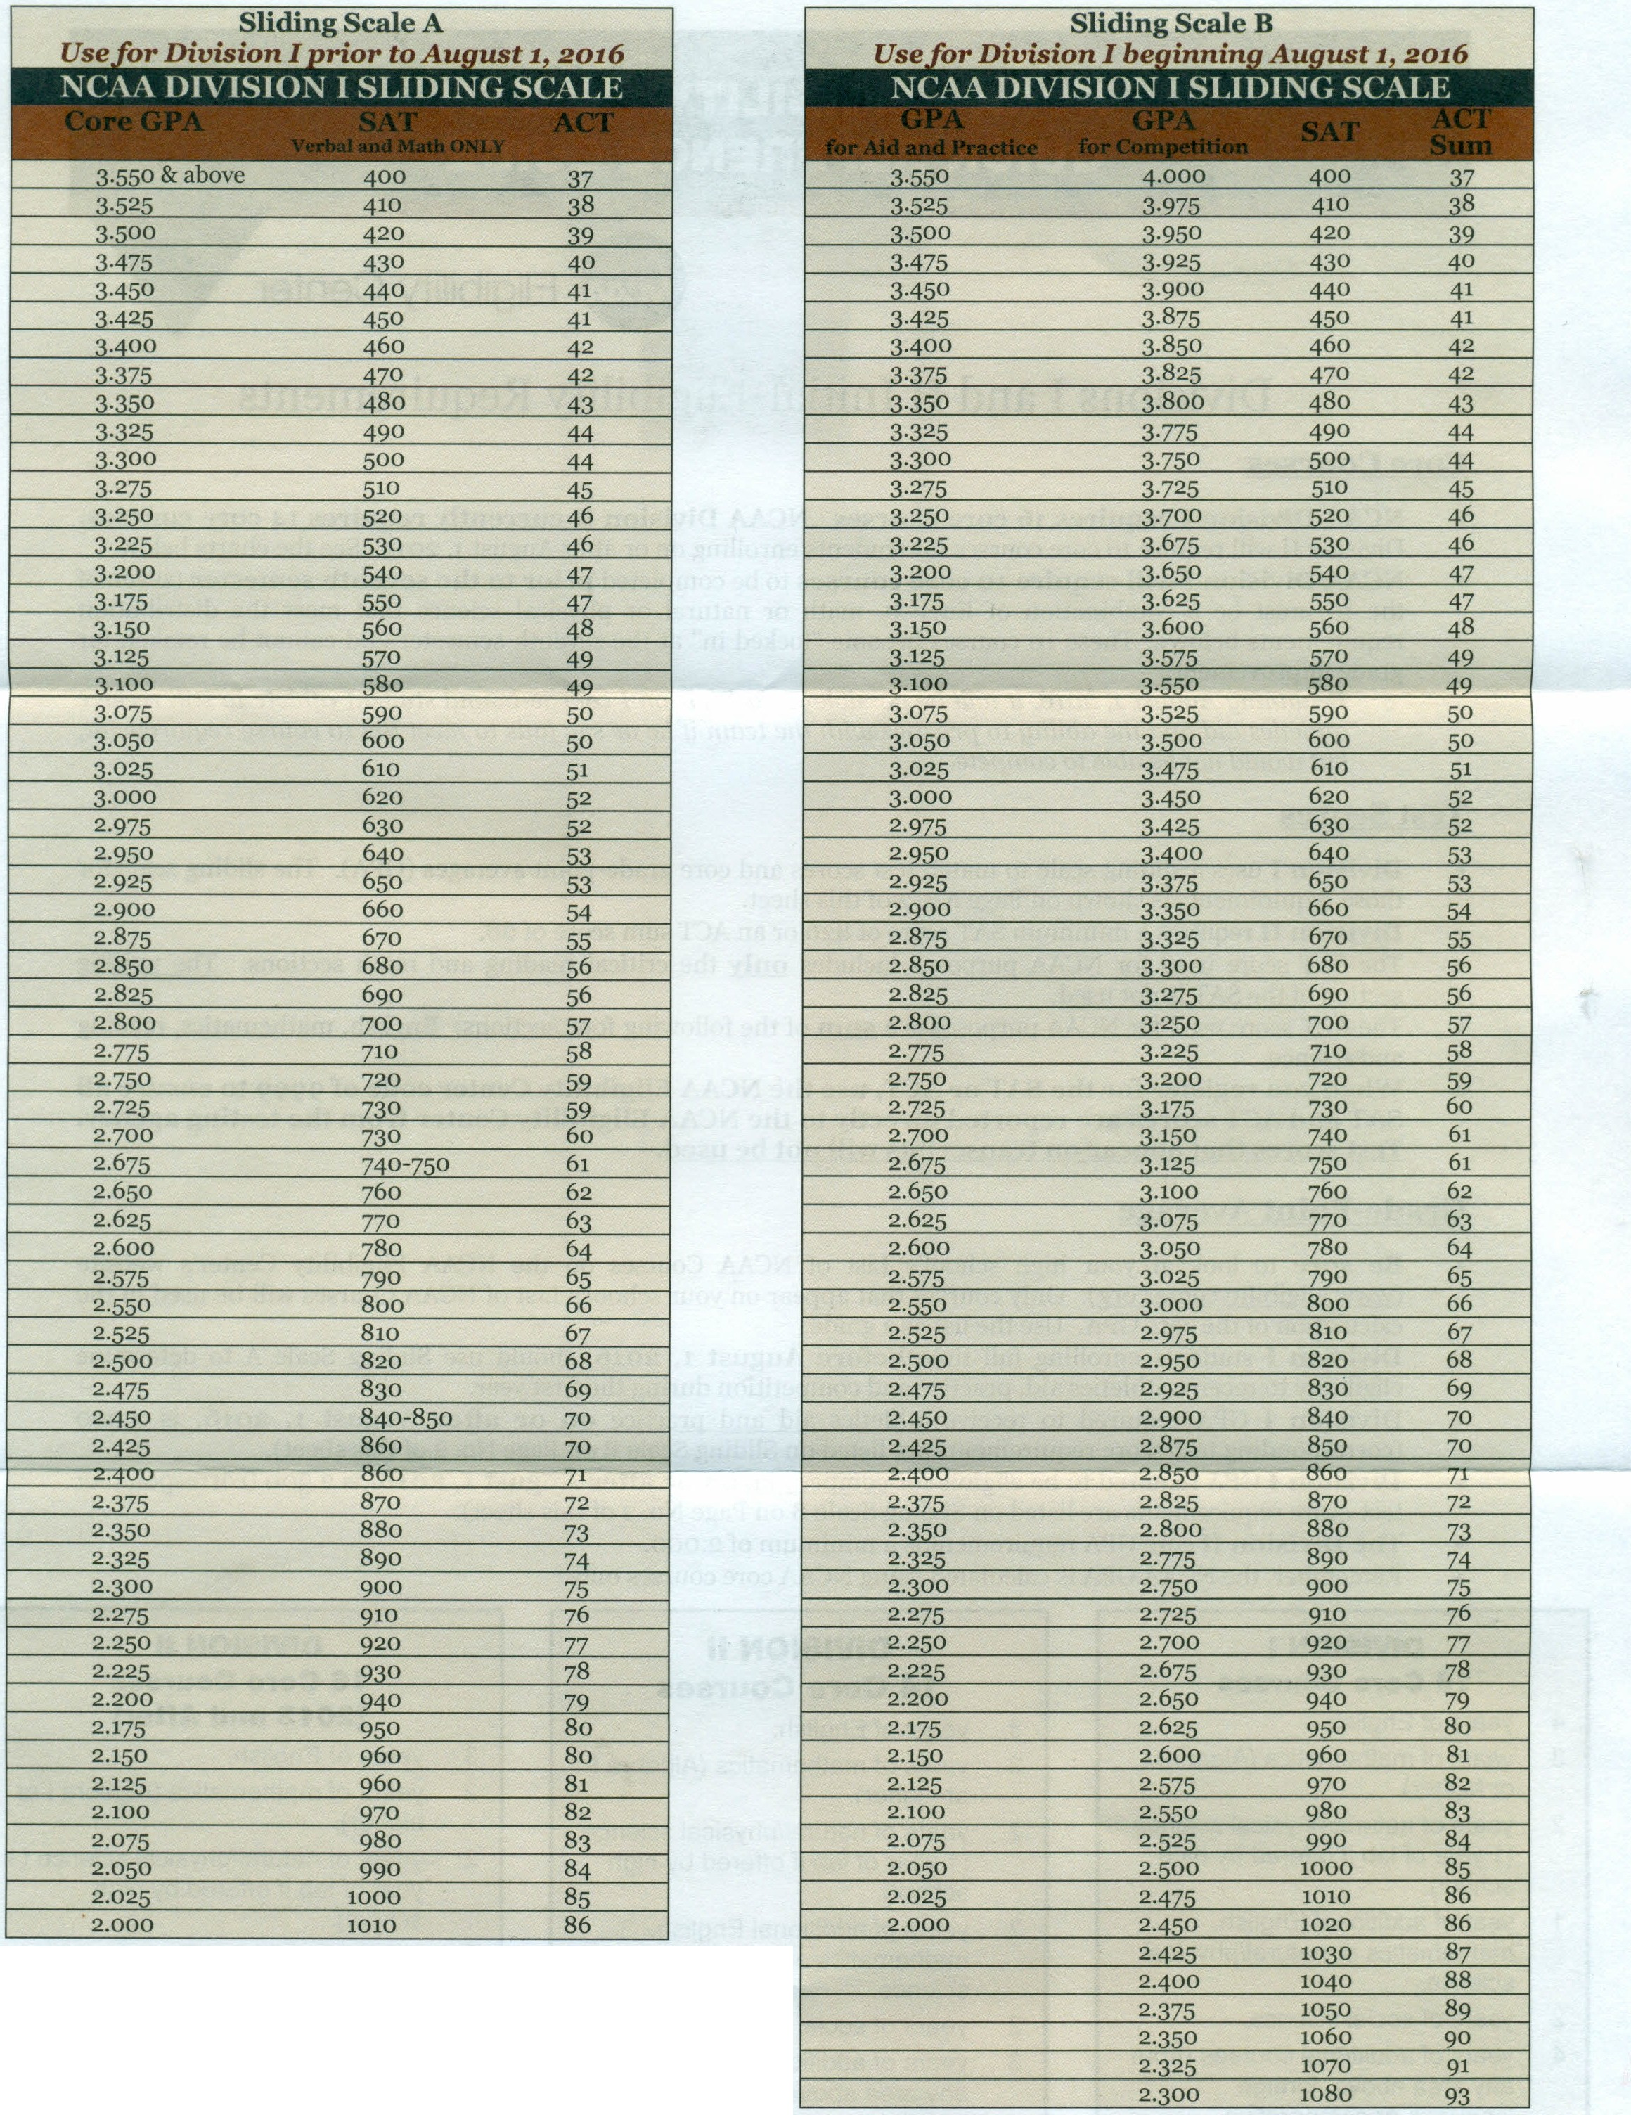

For more information, visit the NCAA Eligibility Center website at www.eligibilitycenter.org.

Page No. 2

